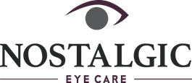

6656 Germantown Avenue
Philadelphia, Pa 19119
Phone: 215-842-5939 | Fax: 215-842-5937
Nec@nostalgiceyecare.com
www.nostalgiceyecae.com

Patient Responsibility Statement

Your medical/vision insurance is not a substitute for payment. Medical/insurance plans vary from plan to plan, and many companies have fixed allowances or percentages based on your contract with them, not with our office. Therefore, it is your responsibility to pay in advance for any co-payments, deductibles, coinsurance, or any other balances not paid for by your insurance company. We will assist you in receiving and filing for benefits as much as possible, but you are responsible in advance for any services rendered.

By signing this statement, you agree to be financially responsible for all charges. Additionally, you authorize our office to utilize any personal/medical information needed to determine benefits payable for related services. This form will remain in effect until revoked by written notice.

Patient Signatue________________________________________________Date__________________

